**Name : Adwait S Purao**

**UID: 2021300101**

**Batch: B2**

**Experiment no.: 6**

**Aim:** To Create a Web Server using Apache2

**Theory:**

Web Server:

• A web server is software and hardware that uses HTTP (Hypertext Transfer Protocol) and other protocols to respond to client requests made over the World Wide Web. The main job of a web server is to display website content through storing, processing, and delivering webpages to users. Besides HTTP, web servers also support SMTP (Simple Mail Transfer Protocol) and FTP (File Transfer Protocol), used for email, file transfer and storage.

• Web server hardware is connected to the internet and allows data to be exchanged with other connected devices, while web server software controls how a user accesses hosted files. The web server process is an example of the client/server model. All computers that host websites must have web server software.

• Web servers are used in web hosting, or the hosting of data for websites and web-based applications -- or web applications.

How do web servers work?

• Web server software is accessed through the domain names of websites and ensures the delivery of the site's content to the requesting user.

• The software side is also comprised of several components, with at least an HTTP server. The HTTP server can understand HTTP and URLs.

• As hardware, a web server is a computer that stores web server software and other files related to a website, such as HTML documents, images, and JavaScript files.

• When a web browser, like Google Chrome or Firefox, needs a file that is hosted on a web server, the browser will request the file by HTTP. When the request is received by the web server, the HTTP server will accept the request, find the content, and send it back to the browser through HTTP.

• More specifically, when a browser requests a page from a web server, the process will follow a series of steps. First, a person will specify a URL in a web browser's address bar. The web browser will then obtain the IP address of the domain name -- either translating the URL through DNS (Domain Name System) or by searching in its cache. This will bring the browser to a web server. The browser will then request the specific file from the web server by an HTTP request. The web server will respond, sending the browser the requested page, again, through HTTP. If the requested page does not exist or if something goes wrong, the web server will respond with an error message. The browser will then be able to display the webpage.

Common and top web server software on the market

There are several common web servers available, some including:

• Apache HTTP Server

• Microsoft Internet Information Services (IIS)

• Nginx

• Lighttpd

• Sun Java System Web Server

Web Server Configuration:

• Web server configuration refers to the process of setting up and customizing a web server to meet the needs of a particular website or application. This involves configuring various settings, such as network protocols, security settings, server-side scripting languages, database connections, and caching rules.

• The configuration process is critical for ensuring that a web server is optimized for performance, security, and scalability. It typically involves modifying configuration files, such as the Apache httpd.conf file or the Nginx configuration file, to specify how the server should handle requests and respond to clients.

• Some common configuration tasks include:

o Setting up virtual hosts to handle multiple websites or domains

o Configuring SSL certificates for secure HTTPS connections

o Enabling server-side scripting languages like PHP or Python

o Configuring caching rules to improve performance

o Configuring access control rules to restrict access to sensitive resources

o Configuring error pages and logging settings for troubleshooting and monitoring

o Web server configuration can be a complex and time-consuming process, but it is essential for ensuring that a website or application is secure, reliable, and performant.

**Apache**:

• Apache is a free and open-source web server software that is widely used for serving web pages over the Internet.

• It was first released in 1995 and has since become one of the most popular web server software packages available.

• Apache is maintained by the Apache Software Foundation, a non-profit organization that supports the development of open-source software.

• Apache is known for its stability, security, and flexibility. It can run on a wide variety of operating systems, including Windows, Linux, and macOS. Apache supports a variety of programming languages, such as PHP, Python, and Perl, and can be extended with modules to add additional functionality.

• Apache uses a modular architecture, allowing administrators to enable or disable features as needed, which can improve performance and security. It is often used in conjunction with other open-source software packages, such as the MySQL database server and the PHP scripting language, to create a complete web development stack known as LAMP (Linux, Apache, MySQL, PHP).

• Apache is licensed under the Apache License, which allows it to be used and distributed freely, including for commercial purposes. It has a large and active community of users and developers who contribute to its ongoing development and support.

**Screenshots:**

1. Install Apache:

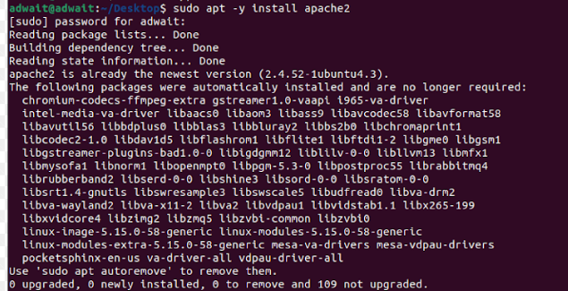

2. Configuring Apache:

• Changing Server Tokens from OS to Prod

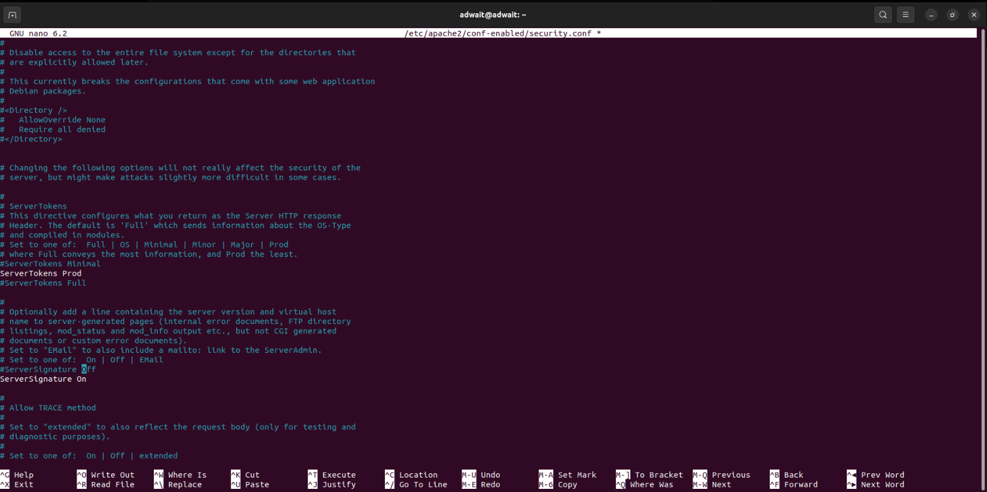

• add file name that it can access only with directory's name

• add to specify server name

• change to webmaster's email

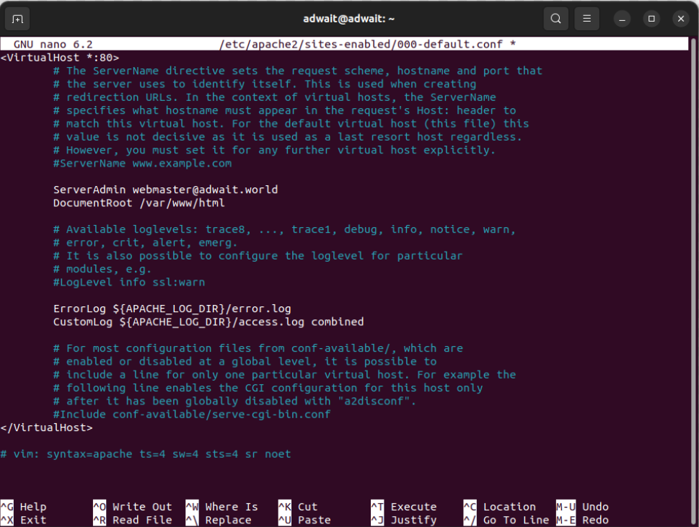

• Restart the Apache Server

Commands Done till this step

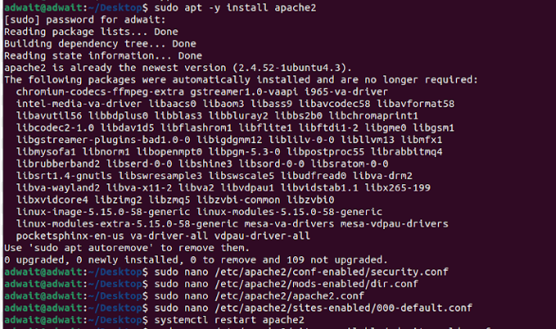

Output:

3. Configuring Virtual Host: Configure Virtual Hostings to use multiple domain names.

For example, Add a new Host setting that domain name is [virtual.host], document root is [/var/www/virtual.host].

• create new settings for new domain

• Giving new configuration

4. Create a test page and access to it from any client computer with web browser. That is OK if following page is shown.

Commands run till now:

Output:

**Conclusion:**

Through this experiment, we gained knowledge on configuring Apache servers, including the creation of our own server and its operation in localhost. We discovered that Apache is a dependable, cost-free, and straightforward approach to establishing a web server. Additionally, we familiarized ourselves with a range of new commands such as a2dissite, systemctl, and a2enssite. By utilizing the systemctl command, we were able to commence, discontinue, reload, and restart our Apache server. Ultimately, our accomplishment was being able to access our custom web page on the web server.